**DAILY ONLINE ACTIVITIES SUMMARY**

|  |  |  |  |  |  |  |  |
| --- | --- | --- | --- | --- | --- | --- | --- |
| **Date:** | 11-06-2020 | | | | **Name:** | Amrutha G | |
| **Sem & Sec** | Fourth sem section A | | | | **USN:** | 4AL18CS006 | |
| **Online Test Summary** | | | | | | | |
| **Subject** | | N/A | | | | | |
| **Max. Marks** | | N/A | | **Score** | | N/A | |
| **Certification Course Summary** | | | | | | | |
| **Course** | Introduction to ethical hacking | | | | | | |
| **Certificate Provider** | | | greatlearning | **Duration** | | | 5 hr |
| **Coding Challenges** | | | | | | | |
| **Problem Statement:**  1: [Write a Java Program to Segregate Even and Odd numbers](https://github.com/orgs/alvas-education-foundation/teams/2nd-year/discussions/114)  2: write a program to print the sum of boundary elements of a matrix | | | | | | | |
| **Status:** completed | | | | | | | |
| **Uploaded the report in Github** | | | | yes | | | |
| **If yes Repository name** | | | | AMRUTHAGANESH/lockdown-java-codings-  AMRUTHAGANESH/lockdown-codings | | | |
| **Uploaded the report in slack** | | | | yes | | | |

**Online Test Details: N/A**

**Online Course Details:**

1. Name of course: **Introduction to ethical hacking**

Certificate provider: greatlearning

In today's session I learnt 2nd module which was about to domain and process implementation under the ethical hacking

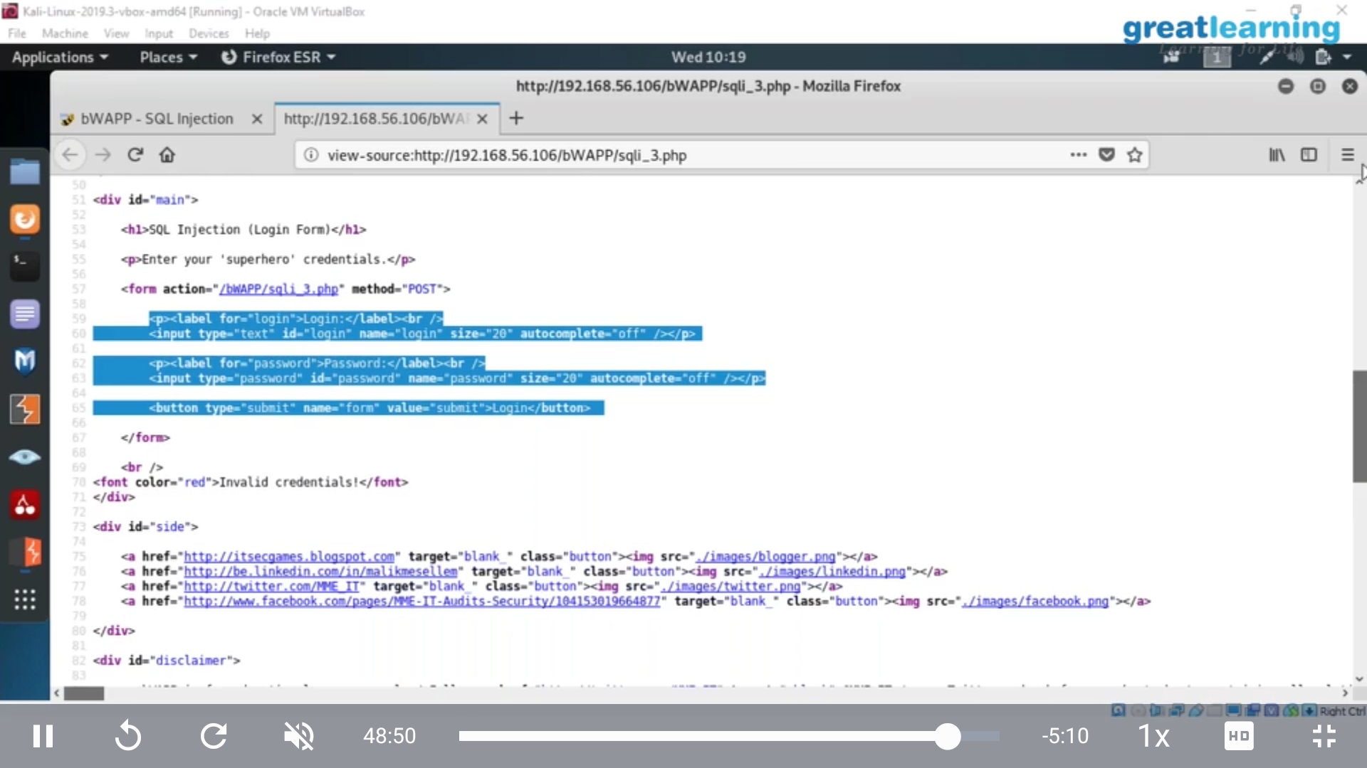

**Online coding:**

Problem 1: [Write a Java Program to Segregate Even and Odd numbers](https://github.com/orgs/alvas-education-foundation/teams/2nd-year/discussions/114)

Problem 2: write a program to print the sum of boundary elements of a matrix

